**Stage 3 – Mad Max**

**RULES:** USPSA Competition Rules, Latest Edition **COURSE DESIGNER:** Ike Starnes

|  |  |
| --- | --- |
| **START POSITION:** Both feet on the Shooting Sports Innovation Xs, facing downrange.  **Handgun**: Loaded and holstered. **PCC**: Loaded, stock on belt. | |
| **STAGE PROCEDURE**  See written stage briefing. | **SCORING**  **SCORING:** Comstock 28 rounds.  **TARGETS:** 11 cardboard targets, 6 steel targets  **SCORED HITS:** 2 Best hits per carboard will be scored. Steel must fall to score.  **START-STOP:**  Audible - Last shot  **PENALTIES:** Per USPSA Competition Rules |

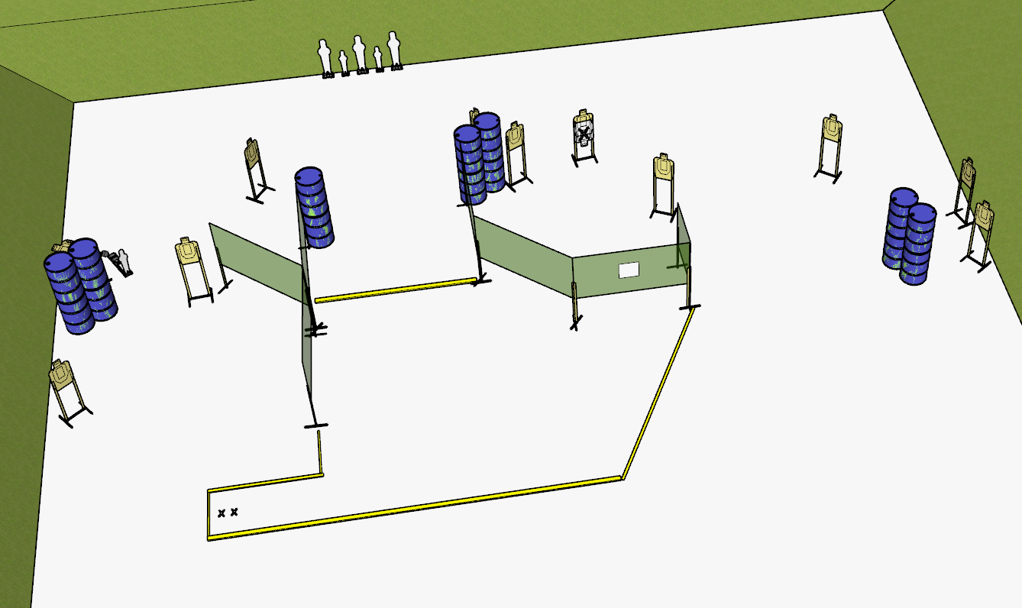

**Written Stage Briefing:**

**Stage 3 – Mad Max –** is a 28-round, 140 point, Comstock Long Course. There are 11 cardboard targets and 6 steel targets. The best 2 hits per cardboard target will be scored. Steel must fall to score.

**Start position** Both feet on the Shooting Sports Innovation Xs, facing downrange.

**Handgun**: Loaded and holstered, wrists below belt.

**PCC**: Loaded, stock on belt, muzzle pointed at center of rear berm.

On the audible start signal, engage targets from within the shooting area.

**Setup Notes:**

5 Single Wall Stands

3 Double Wall Stands

1 Triple Wall Stand

5 Full Walls

1 Half Wall

1 Ported Wall

10 Target stands / 20 Target Sticks

1 Swinger

2 Swinger Target Sticks

1 Activator Plate

3 Poppers

2 Mini Poppers

5 Popper Stands

1 Starting Xs

14+ Barrels